1. **Gantt Chart**

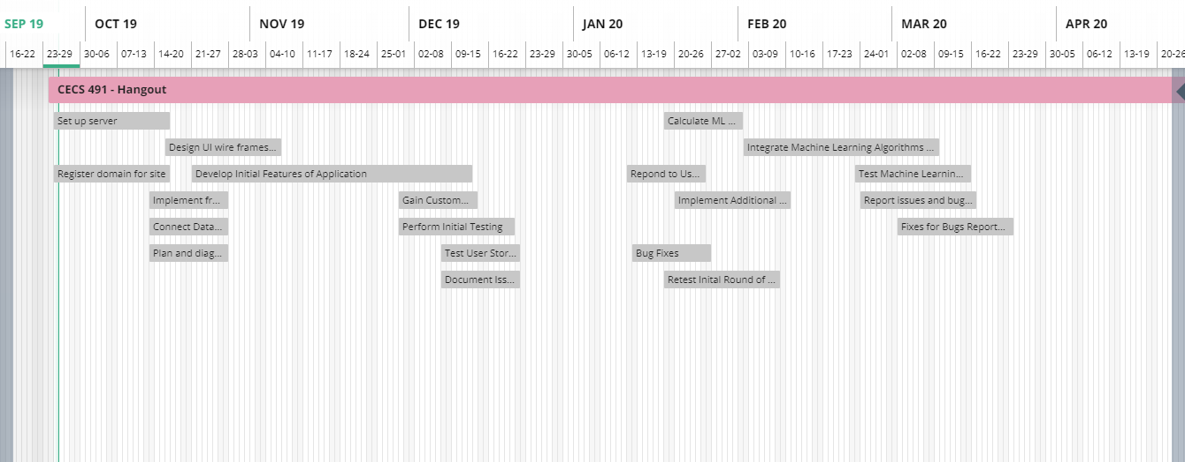

Our gantt chart is a loose planning of what stages of development we want to be at certain points during the year. In the first two to three sprints, we are focused on creating a core architecture and implementation of our product. We plan to implement all the required features first, then test and do bug fixes for the product at that time. Then we will conduct user analysis and surveys to plan what additional features would be preferred for our users, and decide what and how to implement for the next phase of our project. Later in the year we plan on calculating and implementing machine learning algorithms into our product, which will require additional testing.

1. **Project Tracking Matrix**

**Sprint #0**

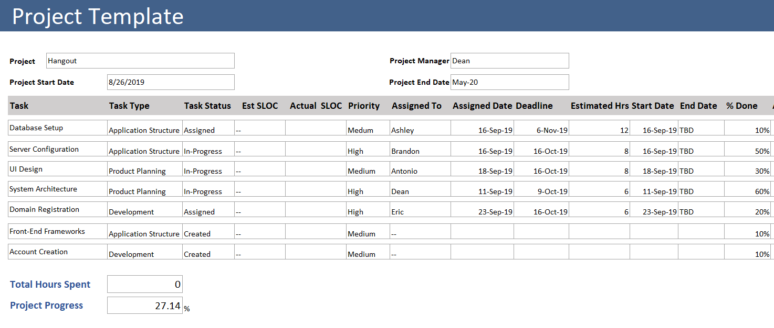

This is the project tracking matrix at the beginning of the semester, during sprint #0. The project tracking matrix at this stage in our product development has focused on initial groundwork needed to begin writing code. We have not started writing any code, so we cannot at this time create a code development velocity calculation. At this time, we are focused on setting up the necessary components for our product. This includes; a database, server, domain, front-end, and back-end. We plan on using React and NodeJS, Firebase, and AWS for those respective components.

**Sprint #3**

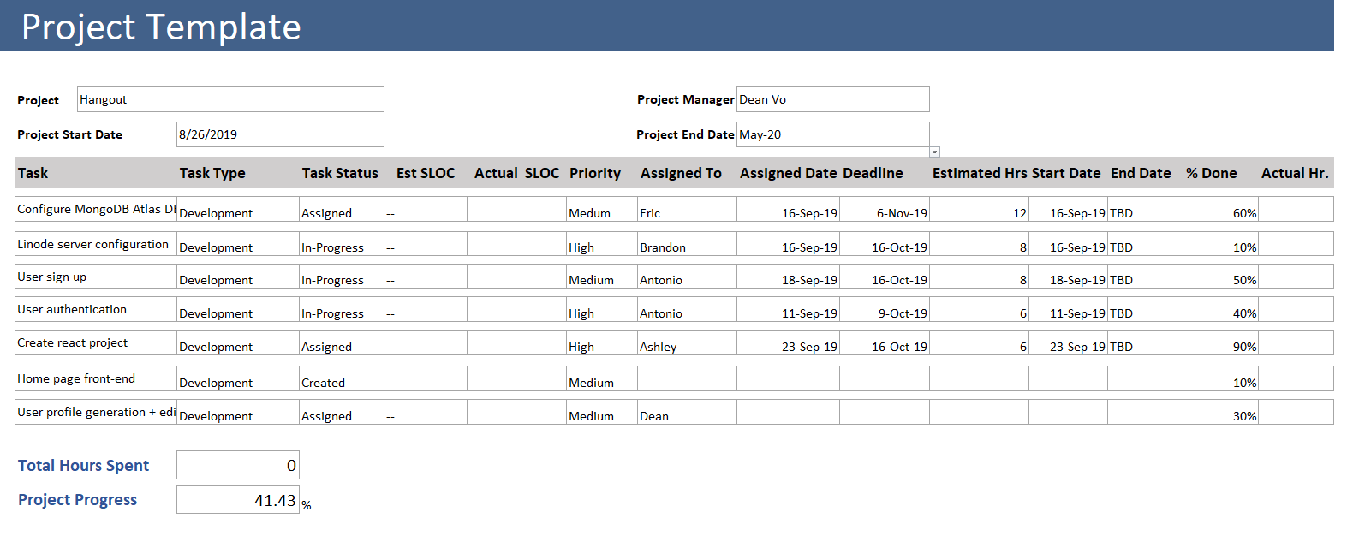

1. **Sprint Board**

**Sprint #0**

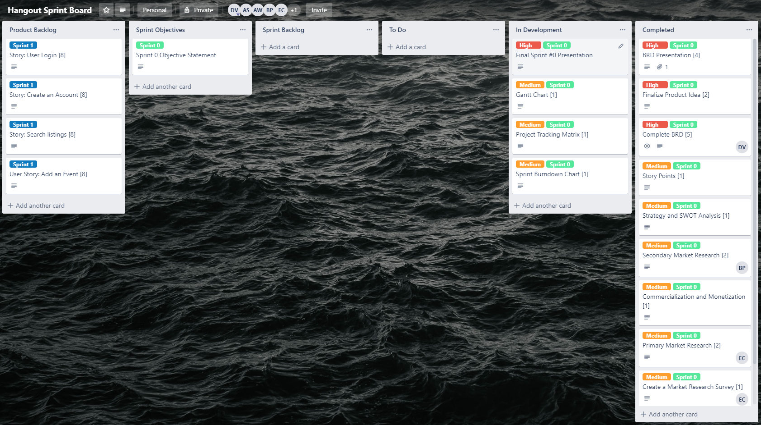

This is our sprint board, consisting of six sections; product backlog, sprint objectives, sprint backlog, to do, in development, and completed. All of these fields are straightforward in their function, and what cards are contained in each. Cards are labeled with a priority; low, medium, or high. Cards are also labeled with what sprint they are contained in, giving more ease in viewing the current progress in the sprint. Each card can be assigned to a member of the team, and each card is labeled in the title with the amount of story points assigned to it.

**Sprint #3**

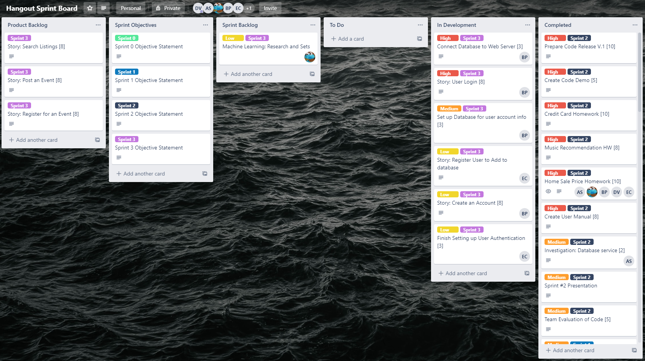

This the sprint board at the conclusion of the semester, end of sprint 3.

1. **Sprint Burndown Chart**

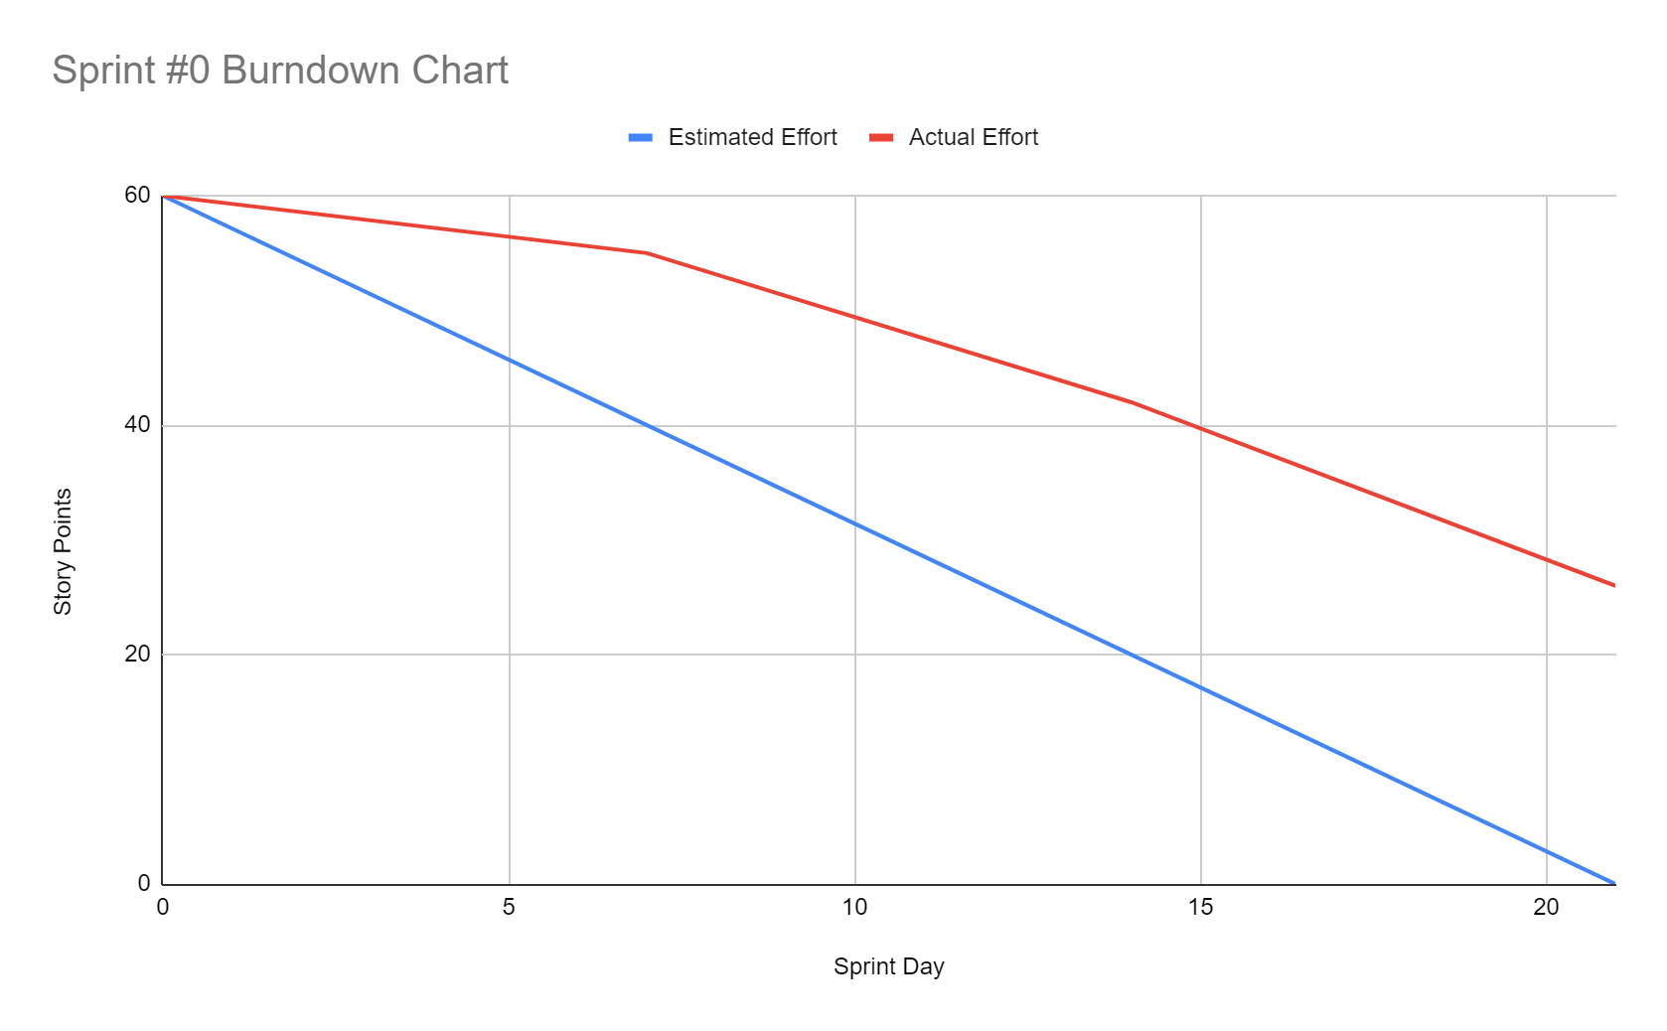

Our sprint burndown has shown that our actual effort has not matched our estimated effort for this sprint. The team sprint capacity for our team was calculated to be sixty hours. For our burndown chart, there are four points in the chart; beginning, end of week one, end of week two, end. This sprint we did not meet our estimated effort because of the nature of this sprint #0 to be a transitory sprint where we are learning agile processes and becoming more familiar with our responsibilities. The beginning of the sprint was not very productive, however the rate of story points being completed increased as the sprint went on. If we can continue this rate for the upcoming sprint, we would be in good shape.

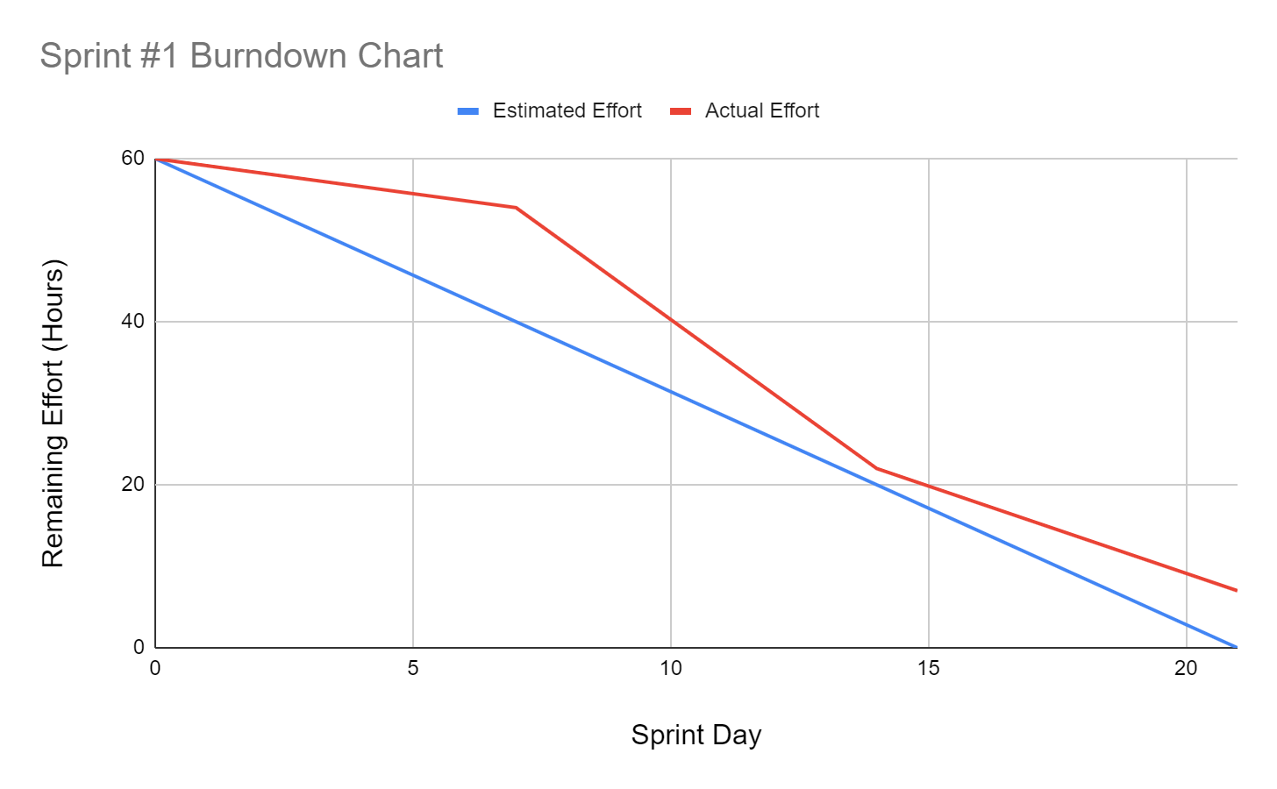

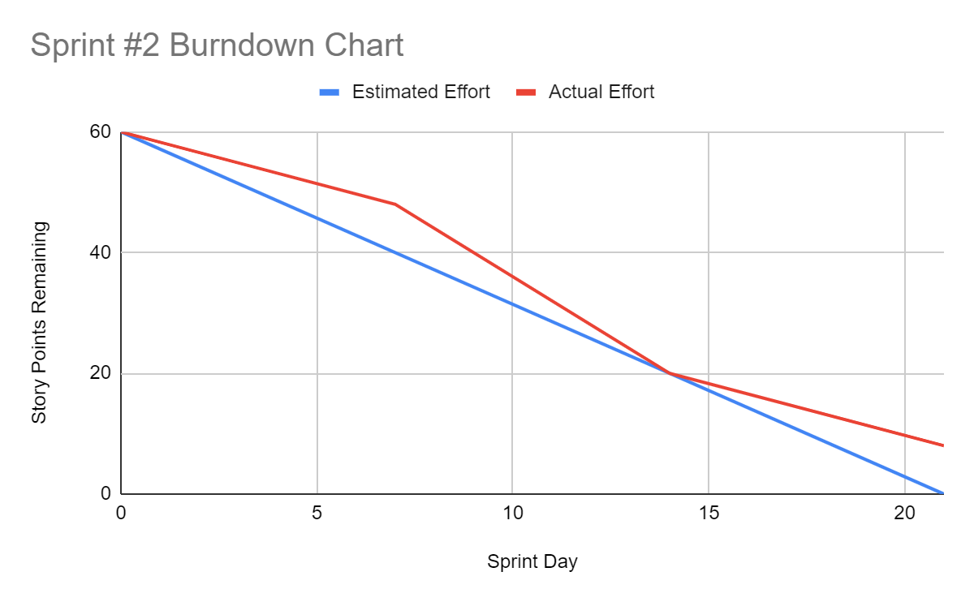

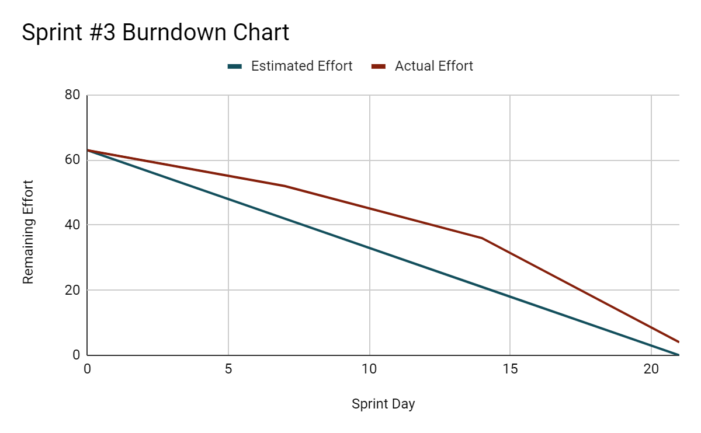

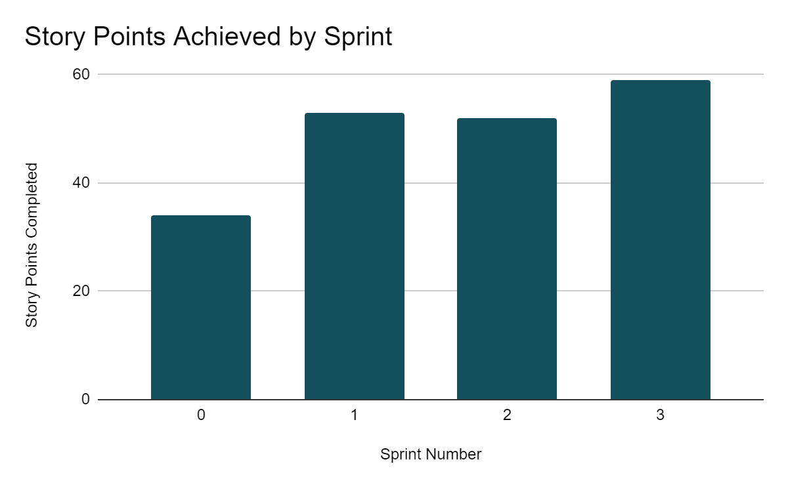

These are all of the sprint burndown charts from Sprints 1-3. The last graph is a bar graph of all our story points completed by Sprint. From the bar graph we are able to draw conclusions of what kind of productivity we are achieving by each sprint easily. That way we can predict how many story points we may be able to complete in future sprints. Additionally, we can see that our productivity has seen a gradual increase throughout the semester. One pattern that we have noticed from all of the sprint burndown charts is that we have consistently fallen short of our planned story points each sprint. This issue lies partly in our ability to complete stories on time, as well as how we estimate story points and development time.

1. **Sprint Retrospective**

**Sprint #0**

*What worked well?*

Overall what went the best during this sprint was our growth as a team. Team chemistry has improved substantially, as well as communication and effort. Initially during the sprint, our communication and understanding of expectations was unclear. However, we now have a greater understanding of our roles, and agile, scrum process. Our team works best when our roles and responsibilities are clearly defined, and each team member has a definite understanding of what work they need to have accomplished.

*What could be improved?*

Improvement is needed in our ability to meet deadlines, work proactively, and our general efficiency. Early in the sprint we were very disorganized, missing deliverable deadlines, and falling behind in our work. The reason for this was partly because as new group members, we were unfamiliar with each other, causing a gap in our communication.

*What did not work well and should be removed?*

Something that is very apparent is that the group responsibilities must be clearly defined in order for our team to be the most productive. If the necessary tasks are not delegated and assigned properly, productivity will be severely diminished.

*What will we commit to doing in the next Sprint?*

This sprint #0 was mostly focused on becoming acclimated with the agile process, coming together as a team, and planning our product idea. The next sprint will be focused on transitioning from coming up with an idea, to making it happen. We will be committed to starting a product that we can start developing. We should have a working product every day, and at this point we have no product at all.

*Overall, what have we learned in this sprint?*

What we have learned in this sprint were all focused towards our team chemistry and how we should implement agile and scrum practices into our team. We learned how to have team sprint planning meetings, delegate work, and communicate our progress.

**Sprint #1**

*What worked well?*

* Task completion
* Maintained good team communication from the last sprint

*What needs improvement?*

* Clarifying requirements
* Confusion on roles and responsibilities among the team

*What are the lessons learned?*

* We must clearly define what is “done” so that stories can be properly tested
* A story is still considered “in progress” until the code has been reviewed

*What are our commitments in the next sprint?*

* Our next sprint we hope to begin code development and code evaluation
* Continue solidifying wireframes and our product design

**Sprint #2**

*What worked well?*

* Team chemistry and resolve
* Inter-team relations, communication, and collaboration

*What needs improvement?*

* Time management: we spent too long on less priority tasks, leaving less time for the high priorities
* Proactivity: team members often waited until the last minute to complete deadlines and begin work

*Overall, what have we learned?*

* Machine learning introduction
* How much planning we need to do before any actual development

*What are we committing to in the next sprint?*

* Continuing code development
* Maintaining a high level of productivity

**Sprint #3**

*What went well?*

* Great effort from all team members: all members worked with a sense of urgency and proactivity that was not seen in previous sprints
* Development execution: we had our most productive sprint from a story point stand-point

What could be better?

* Working concurrently: teammates are working on different aspects of the product independently, lacking synergy
* Accurate planning: we need to have greater attention to detail when planning stories
* Improving version control implementation

Conclusions?

* Stories and code development will often take longer than we initially anticipate

What are we committing to in the next sprint?

* Continue code development more cohesively
* Build out more user stories
* Focus on front-end development